PACKAGE DROP TEST MACHINE
INQUIRY FORM
I.Test product specs:

- Test product name：

- Test product dia： （L*W*H）

- Test product weight： （kg)

II. Test conditions：

- Max drop height：

- Min drop height：

- Drop method：¨Free drop ¨Directional drop

- Baseplate material：¨Steel plate ¨Cement ¨Wood board ¨Marble（Standard configuration is steel plate）

- Drop measurement system：¨Required ¨Not required （Triaxial acceleration value when test product drops）

- Other request：

III.Product photo：

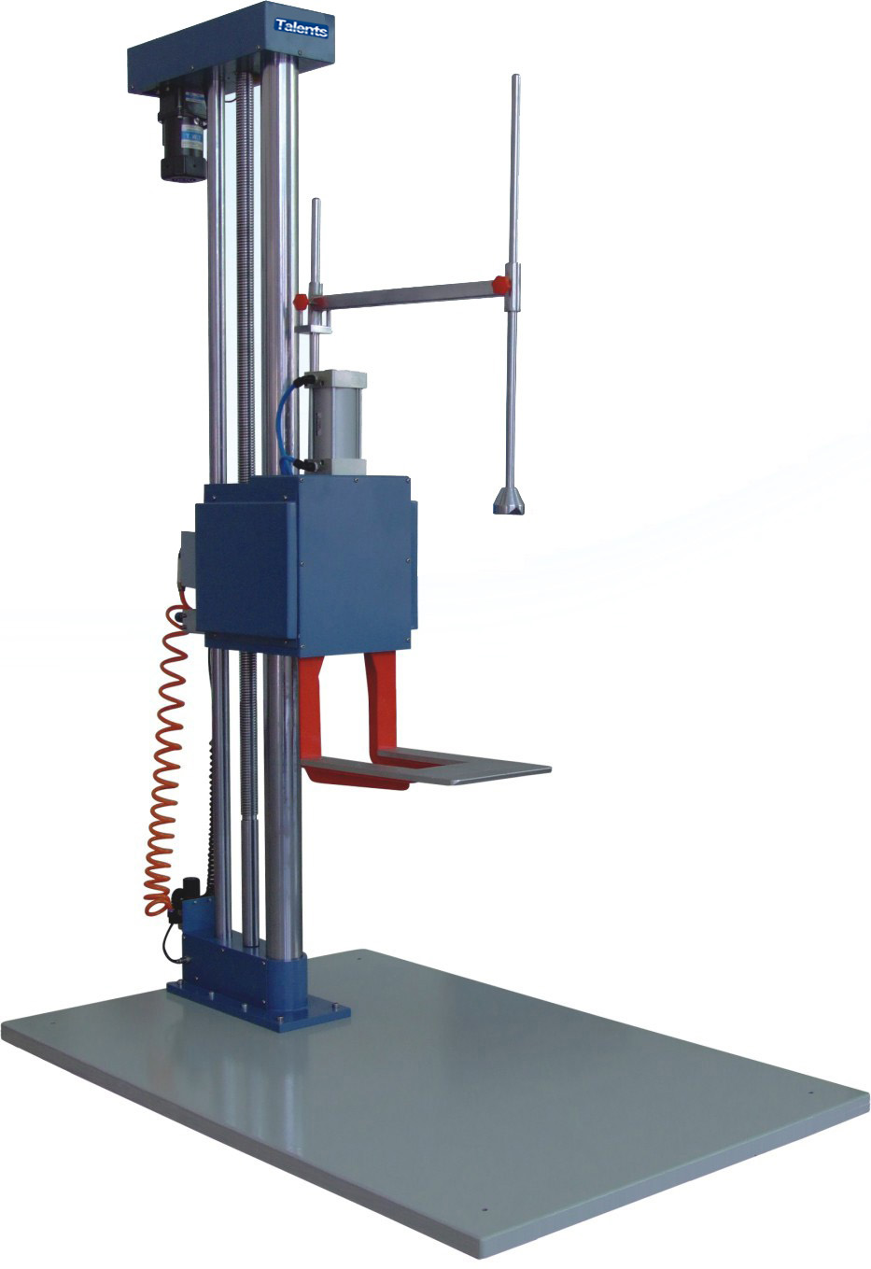

Our company has all kinds of mechanics, temperature, weather resistance reliability test equipment such as triaxial acceleration drop measurement system, zero height drop test machine, portable drop test machine, etc. for customers to choose from, Welcome to contact us.

